Executive Summary This report is compiled as required by the Bylaws of our organization and summarizes the activities, challenges, and progress made during the 2025–2026 reporting period. Throughout 2025 the Board of Directors met monthly, with the exception of meeting in November, to guide the organization through a year marked by strategic reflection, operational change, and important decisions about the future of our facilities and programs.
Like many community organizations, we continue to experience lingering impacts from the post‑COVID environment. Membership numbers declined, volunteer participation became more difficult to sustain, and community engagement in events remained limited. In response, the Board conducted an extensive strategic planning effort and evaluated seven potential future strategies, including dissolution of the organization.
After careful consideration, two priorities emerged: strengthening community connection through programs and activities, and investing in our facilities to generate sustainable revenue. In 2025 the organization invested approximately $36,000 into improvements to the Community Hall including roof repairs, new flooring, upgraded lighting, and interior improvements. These investments were intended to increase rentals and strengthen the organization’s financial sustainability.
Unfortunately, economic conditions across the region resulted in fewer rentals than anticipated, and the financial return on these investments has not yet met expectations. Despite this challenge, the improvements position the facility for stronger community use moving forward.
The Board also began exploring partnerships with local nonprofits and government agencies, including significant discussions with Friends of the Verde River. These conversations may lead to a long‑term partnership that supports both organizations while strengthening the community role of our facilities.
During this year the Board also made several difficult but necessary decisions, including the permanent closure of the community pool due to the significant financial and volunteer resources required to operate it safely. Additionally, discussions have begun with Yavapai County regarding the potential future of the Del Rio Pond property.
While the year presented real challenges, it also marked an important period of transition as the organization adapts to changing realities while continuing to serve the Verde Village community.
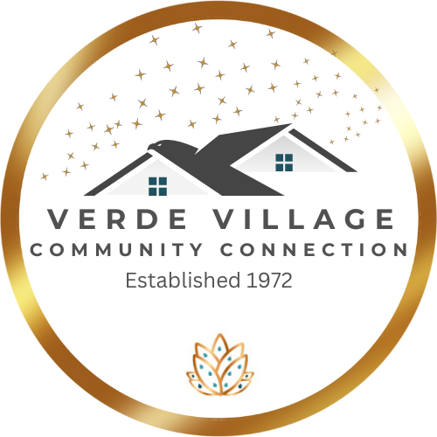  Annual report  2025 - 2026 | Presented by:  Aislinn Maldonado  President

The Board of Directors consists of the following members:
Aislinn Maldonado | President
Jeff Raible | Treasurer
Dina Ribaudo | Secretary
Cheryl Kasdorf | Public Relations Chair
Dan Streichan | Maintenance Chair
Daniel Maldonado | Highway Clean-up Chair
Dennis Kuhn | Nature Preserve Chair
Robert Kielblock | Membership Chair
Ron Bennett | Pond Chair
Ashley Betancourt | Board Member
David Hoover | Board Member
Gwendolyn Kielblock | Board Member
Wendy McCants | Board Member
Sylvia Martinez | Board Member

Connections and Volunteers
We started 2025 with a total of 16 Board Members. Due to some changes in people’s lives, we are now a board consisting of 14 Board Members. This is an election year, and that number may change but for the most part our Board of Directors will remain the same. This past year we have established an additional 500 connections from previous years. These connections consist of Volunteers, Pool Monitors, New Members, Event Attendees, Meeting Attendees, Facility Rentals and the last remaining Membership Bags.
Community Events
In 2025 our community events were intentionally limited as we focused on listening to residents and evaluating how the organization can better support the needs of the Verde Village community.
While fewer events were held, we continued to host long‑standing traditions such as the Luau and Trunk or Treat, both of which continue to bring neighbors together and create opportunities for families to connect.
Our focus during the year shifted toward strengthening relationships, encouraging community dialogue, and evaluating how our properties and programs can best serve the community moving forward.
Financial Summary
This year presented significant financial challenges. Membership reached its lowest point with only 72 active members before increasing slightly to 95 active memberships as of the official member of record date on February 28, 2026.
Liability insurance costs increased again this year to $16,600, compared to approximately $14,000 the previous year and roughly $6,000 several years ago. This increase significantly impacted the organization’s operating budget.
In addition, the organization invested nearly $36,000 in improvements to the Community Hall in an effort to increase rentals and strengthen long‑term financial sustainability.

Strategic Plan
In response to declining memberships, reduced volunteer availability, and lower community participation following the COVID‑19 pandemic, the Board undertook a comprehensive strategic planning process. Seven possible strategies were evaluated, including the possibility of dissolving the organization.
After careful consideration, two primary priorities were selected:
• Provide programs and activities that foster community connection.
• Invest in facilities to increase rental revenue and long‑term sustainability.
A cornerstone of this strategy is building partnerships with local nonprofits and government agencies.

Facility Investment Strategy
The Verde Valley has relatively few large meeting venues, and the Community Hall offers competitive pricing compared with other locations in the region. In order to improve the facility and increase its appeal for rentals, approximately $36,000 was invested into repairs and improvements including roof repairs, new flooring, upgraded lighting, and general interior improvements.
Financial Reality
Although the strategy was developed and implemented in good faith, broader economic conditions resulted in fewer rentals than expected. As a result, the return on investment has not yet met projections and the organization faces increased financial risk.

VVCC Properties
Community Hall – The Community Hall continues to serve as an important gathering space within the community. During the year our facility hosted about half as many rentals. It did get continued community uses, including a local Hula group, a homeschool group, and even a dog training group.

Community Pool – Following the 2025 swim season, the Board made the difficult decision to permanently close the community pool. Safe operation of the pool required significant financial investment as well as extensive volunteer coordination. Although the pool showed a small profit in 2025, that result occurred only because no major investments were made beyond basic break‑fix repairs.

Del Rio Pond – The Del Rio Pond property continues to present long‑term challenges due to water supply and maintenance requirements. Discussions have begun with Yavapai County regarding the potential transfer of the property. The County has expressed interest in possibly developing the area as the first regional park in District 3, which could provide financial resources and professional management of the site.
Nature Preserve –We are currently in the final stages of negotiating a long term lease agreement with the gifting of the Nature Preserve to the Friends of the Verde River regarding them assuming this property because we feel they will best maintain this property.
Conclusion
This year has been another stellar year of reflection, transition, and resilience. The organization continues to adapt to changing circumstances while remaining committed to strengthening community connections and preserving important community spaces.
We invite residents and members to remain engaged, participate in upcoming programs, and help shape the future of the organization.

“Alone, we can do so little, together, we can do so much” – Helen Keller

